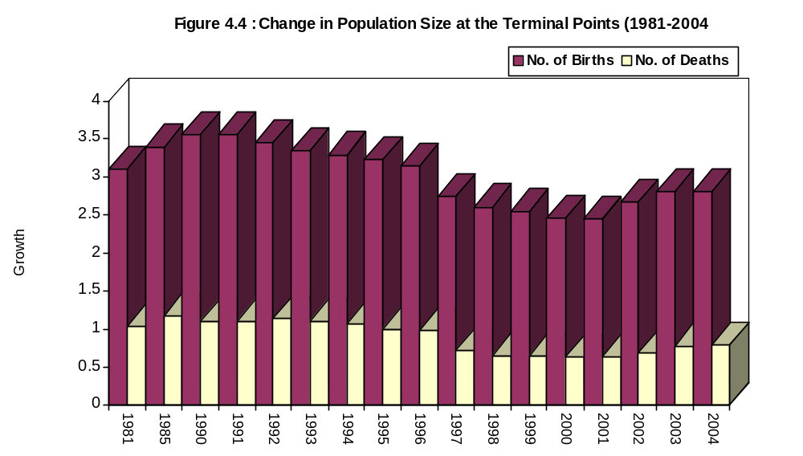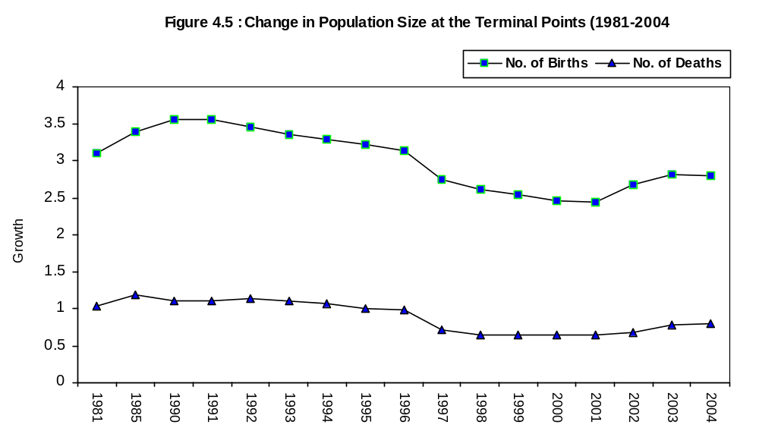

24

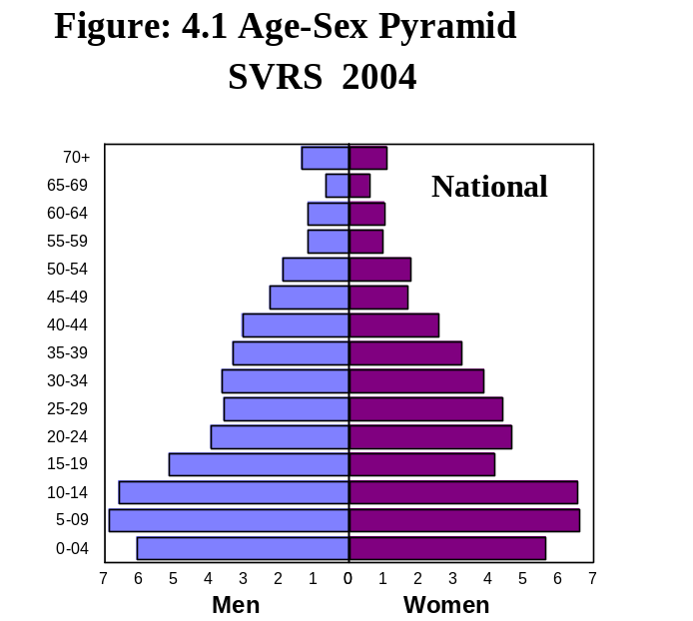 | 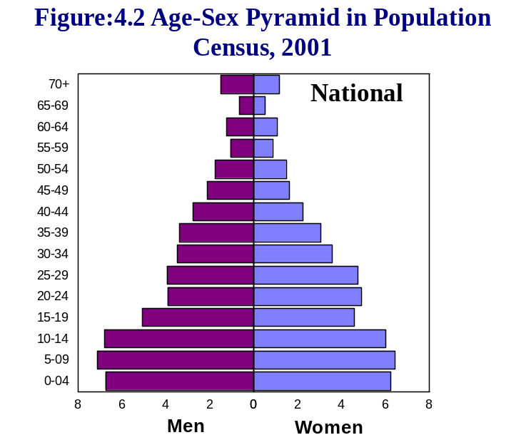
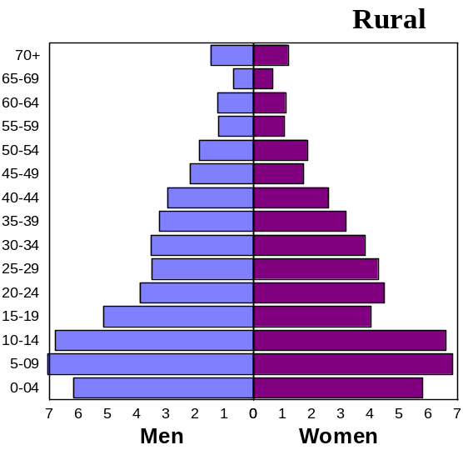 | 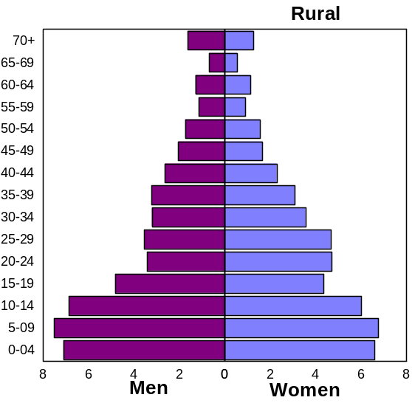
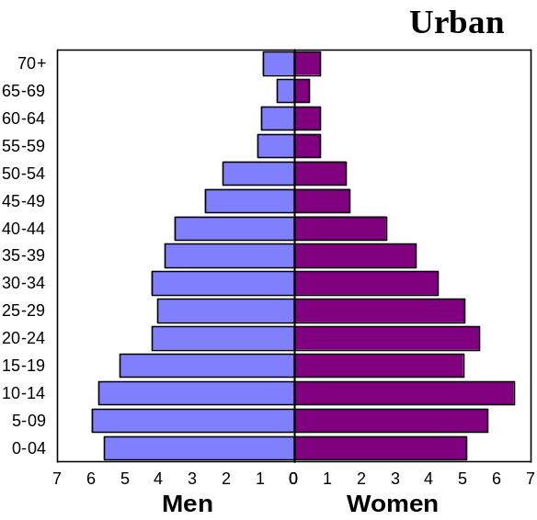 | 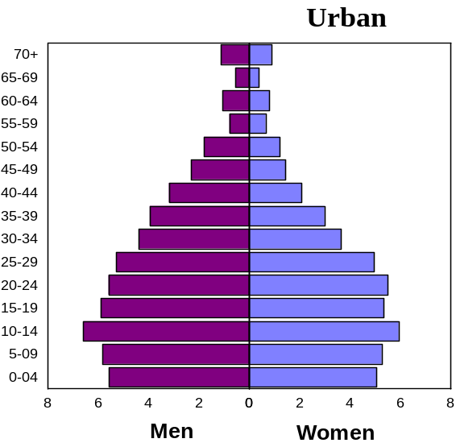

29

Chapter-5
Fertility
Fertility refers to the role of birth in population change and human reproduction. Patterns, levels and trends of fertility in Bangladesh are therefore, urgently needed for formulation and successful implementation of population control and health programme. Data on births was collected with birth card (Schedule-3). With this schedule data on population, mothers line number, sex, date of birth, registration status, date of registration, place of birth, type of birth, live births, survival status, mother’s name, mothers age, mothers education and total live birth were collected by the dual recording system. In this report estimated number of births, crude birth rate, age specific fertility rate, total fertility rate, total marital fertility rate, general fertility rate, gross reproduction rate and net reproduction rate have been incorporated.

5.1 Crude Birth Rate
Crude birth rate (CBR) per 1000 populations for 1981-2004 presented in Table 5.1 It shows the trends of CBR over time 1981-2004.
T5.1 Crude Birth Rate per 1000 Population by Locality 1981-2004
Year | National | Rural | Urban
1981 | 34.6 | 35.7 | 24.8
1982 | 34.8 | 36.9 | 22.9
1983 | 35.0 | 36.4 | 27.1
1984 | 34.8 | 36.1 | 25.0
1985 | 34.6 | 35.3 | 28.0
1986 | 34.4 | 35.4 | 25.9
1987 | 33.3 | 34.6 | 24.8
1988 | 33.2 | 34.6 | 24.9
1989 | 33.0 | 34.5 | 24.4
1990 | 32.8 | 34.3 | 24.6
1991 | 31.6 | 32.9 | 23.9
1992 | 30.8 | 32.2 | 23.7
1993 | 28.8 | 30.0 | 21.0
1994 | 27.0 | 29.1 | 20.2
1995 | 26.5 | 28.5 | 19.4
1996 | 25.6 | 27.8 | 19.0
1997 | 21.0 | 24.5 | 16.2
1998 | 19.9 | 21.0 | 14.0
1999 | 19.2 | 20.9 | 13.8
2000 | 19.0 | 20.8 | 13.7
2001 | 18.9 | 20.7 | 13.6
2002 | 20.1 | 21.0 | 16.6
2003 | 20.9 | 21.7 | 17.9
2004 | 20.8 | 21.6 | 17.8
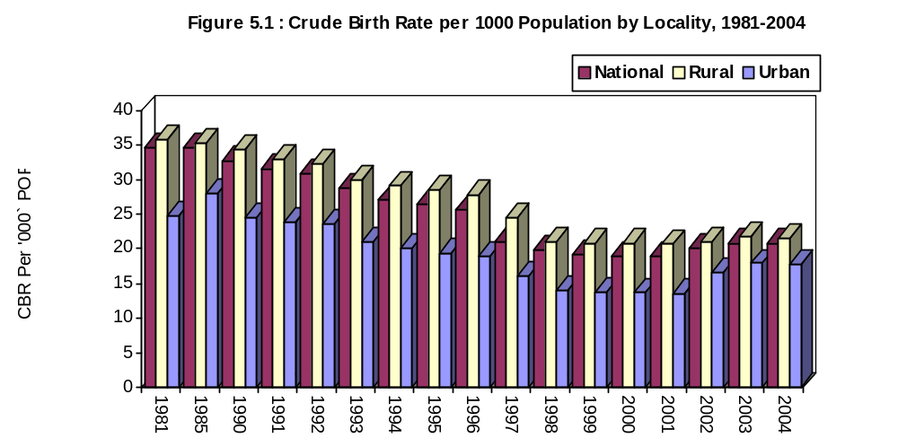

It revealed from the table that the crude birth rate was 34.6 in 1981, 33.3 in 1987 and 20.8 in 2004. In rural areas these rates were 35.7, 34.6 and 21.6 respectively. In urban areas these rate were 24.8, 24.8 and 17.8 respectively.
37

T5.7 Total Fertility Rate (TFR) Per Woman by Locality for 1981-2003

Year | National | Rural | Urban
1981 | 5.04 | 5.28 | 3.20
1982 | 5.21 | 5.50 | 3.01
1983 | 5.07 | 5.36 | 3.45
1984 | 4.83 | 5.08 | 3.10
1985 | 4.71 | 4.91 | 3.52
1986 | 4.70 | 4.89 | 3.26
1987 | 4.42 | 4.64 | 3.05
1988 | 4.45 | 4.70 | 3.08
1989 | 4.35 | 4.59 | 2.90
1990 | 4.33 | 4.57 | 2.90
1991 | 4.24 | 4.51 | 2.89
1992 | 4.18 | 4.33 | 2.88
1993 | 3.84 | 4.00 | 2.62
1994 | 3.58 | 3.79 | 2.58
1995 | 3.45 | 3.78 | 2.50
1996 | 3.41 | 3.76 | 2.48
1997 | 3.10 | 3.32 | 2.28
1998 | 2.98 | 3.00 | 2.24
1999 | 2.64 | 2.91 | 1.76
2000 | 2.59 | 2.89 | 1.68
2001 | 2.56 | 2.84 | 1.73
2002 | 2.55 | 2.69 | 1.94
2003 | 2.57 | 2.70 | 1.91
2004 | 2.52 | 2.69 | 1.90

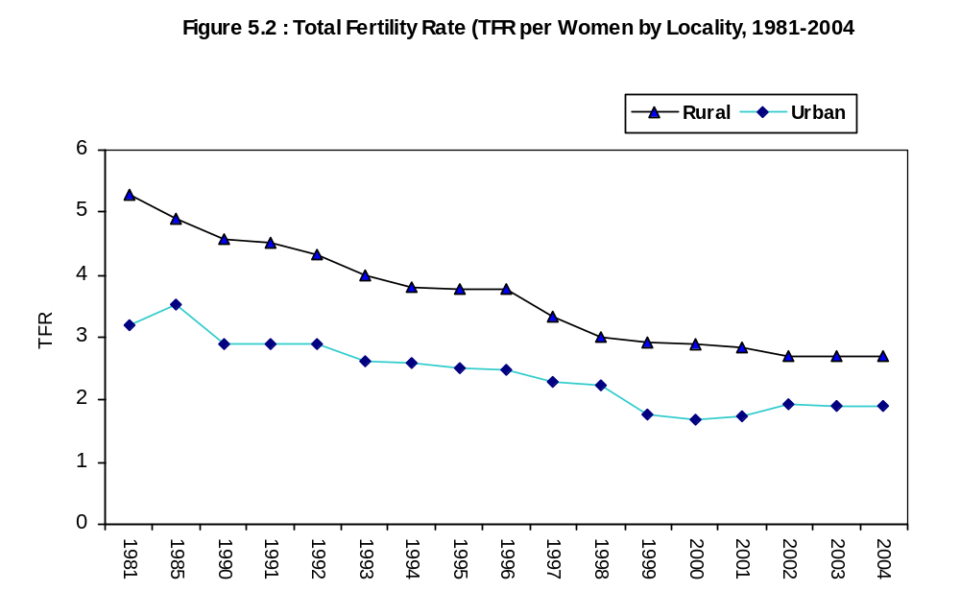

44

5.7 Gross Reproduction Rate
Gross Reproduction Rate (GRR) measures the average number of daughters a woman will have during her life time if she passes through child bearing ages experiencing average age-specific fertility pattern of a given year.

T5.13 Gross Reproduction Rate (GRR) and Net Reproduction Rate (NRR) per Woman by Locality for 1981-2003

Year | GRR |  |  | NRR
Year | National | Rural | Urban | National | Rural | Urban
1981 | 2.50 | 2.61 | 1.50 | 1.89 | 1.96 | 1.32
1982 | 2.54 | 2.68 | 1.48 | 1.98 | 2.07 | 1.26
1983 | 2.45 | 2.59 | 1.66 | 1.92 | 2.01 | 1.41
1984 | 2.34 | 2.47 | 1.50 | 1.81 | 1.81 | 1.36
1985 | 2.20 | 2.37 | 1.72 | 1.79 | 1.83 | 1.41
1986 | 2.29 | 2.38 | 1.57 | 1.80 | 1.87 | 1.28
1987 | 2.14 | 2.25 | 1.48 | 1.69 | 1.74 | 1.17
1988 | 2.21 | 2.31 | 1.57 | 1.74 | 1.80 | 1.22
1989 | 2.10 | 2.26 | 1.41 | 1.72 | 1.79 | 1.20
1990 | 2.10 | 2.22 | 1.42 | 1.71 | 1.76 | 1.20
1991 | 2.06 | 2.17 | 1.38 | 1.70 | 1.74 | 1.19
1992 | 2.03 | 2.14 | 1.37 | 1.68 | 1.72 | 1.18
1993 | 2.01 | 2.12 | 1.32 | 1.57 | 1.70 | 1.25
1994 | 1.81 | 1.98 | 1.25 | 1.48 | 1.65 | 1.12
1995 | 1.68 | 1.85 | 1.20 | 1.48 | 1.68 | 1.09
1996 | 1.66 | 1.84 | 1.19 | 1.46 | 1.64 | 1.08
1997 | 1.52 | 1.63 | 1.10 | 1.37 | 1.62 | 1.07
1998 | 1.45 | 1.62 | 1.08 | 1.31 | 1.43 | 1.06
1999 | 1.29 | 1.44 | 0.86 | 1.25 | 1.39 | 0.82
2000 | 1.27 | 1.41 | 0.82 | 1.24 | 1.37 | 0.79
2001 | 1.26 | 1.40 | 0.80 | 1.23 | 1.36 | 0.79
2002 | 1.26 | 1.32 | 1.03 | 1.22 | 1.29 | 0.94
2003 | 1.24 | 1.32 | 0.95 | 1.20 | 1.29 | 0.92
2004 | 1.21 | 1.28 | 0.92 | 1.18 | 1.25 | 0.91

It is apparent that GRR of rural area was more than that of urban area by 0.36 points. It is also evident from the above table GRR has reduced by 0.03 points during 2003-04 with 0.04 points in rural area and 0.08 points in urban area. Trends in GRR can be seen from the table T5.13 for the period 1981-2004.
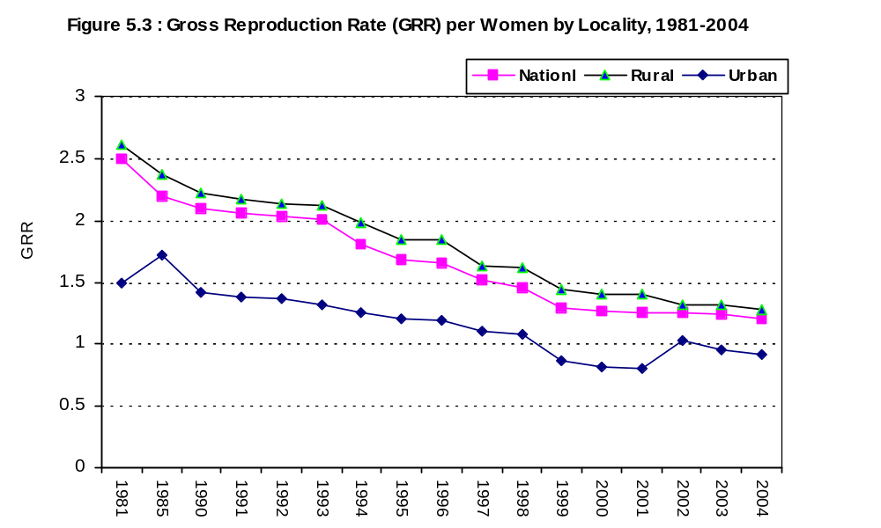

49

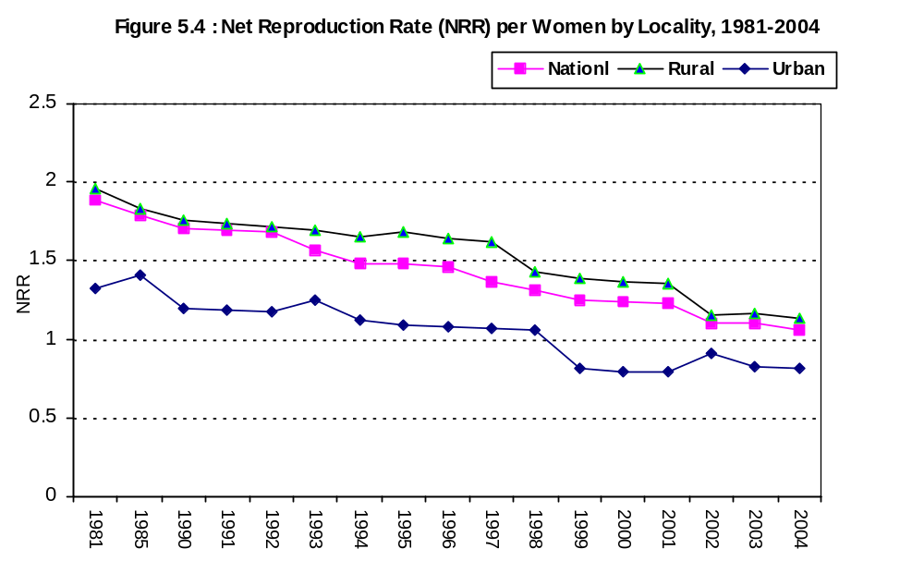

5.8 Net Reproduction Rate
The net reproduction rate (NRR) is a measure of the number of daughters that a cohort of new born girl babies will bear during their life time assuming a fixed schedule of age specific fertility rate and a fixed set of mortality rates. Thus, NRR is a measure of the extent to which a cohort of newly born girls will replace themselves under given schedules of age specific fertility and mortality. In NRR adjustment were made for the number of girls who died before attaining reproductive age and those who died during child bearing period. It is seen that NRR of rural area was higher than that of urban area by 41.0%. To observe the levels and trends NRRs have been shown side by side with GRR in table T5.13 for the period 1981-2004. It is apparent from the table that NRR has reduced by 41.8% during 1981-2004. During the same period NRR of rural area had reduced by 40.3% and that of urban area had reduced by 37.1%.

510

It is evident from the table that CDR has reduced in both the urban and rural areas during 1981-2004. At the national level it had decreased from 11.5 in 1981 to 11.2 in 1991 and to 5.7 in 2004. In case of rural the reduction trend was 12.2 in 1981 to 11.5 in 1991 and to 6.0 in 2004 and in case of urban the corresponding CDRs were 7.2, 7.8 and 4.4.
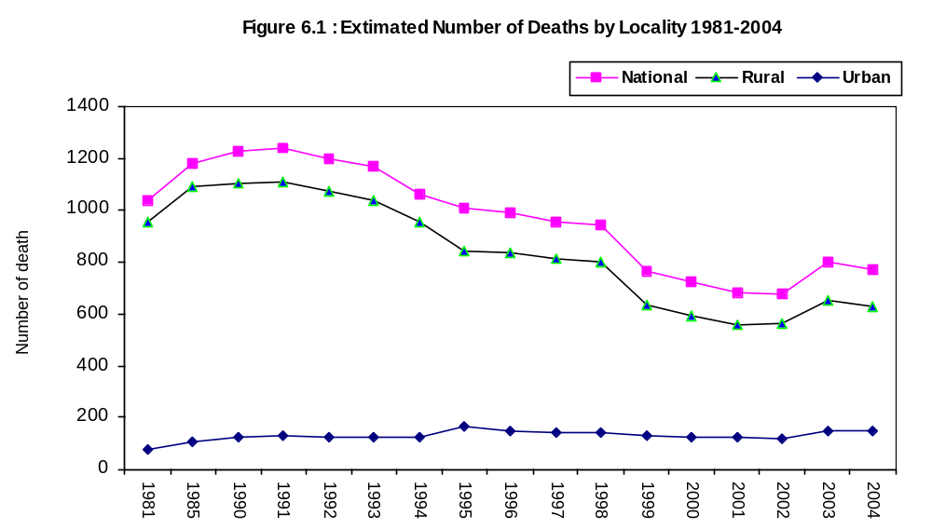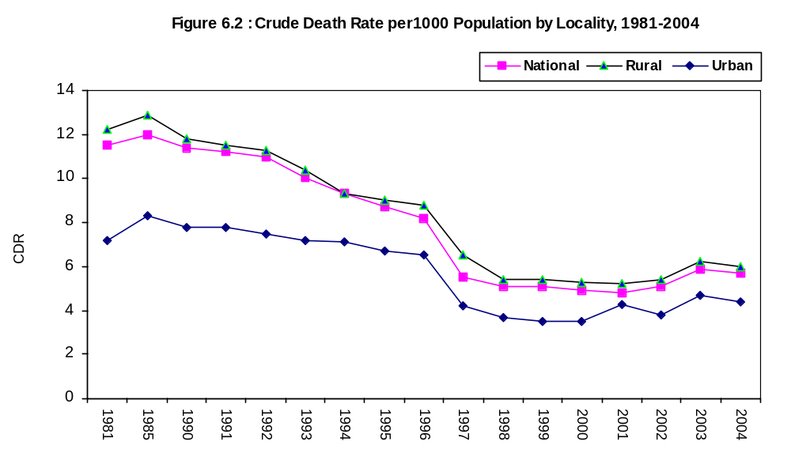

530

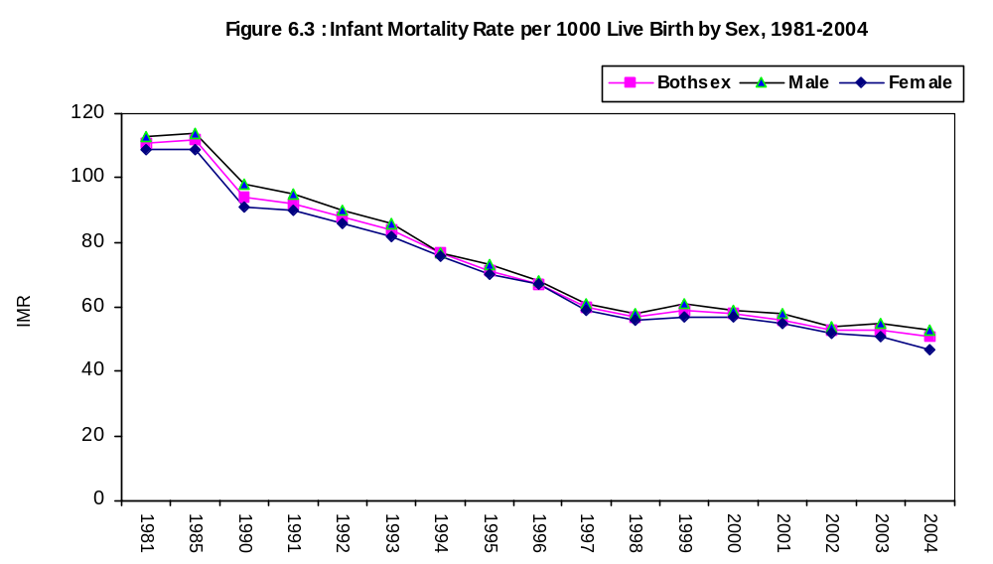

Regional Differentials in IMR
Divisionwise trend in IMR by sex and locality can be seen in table T6.10 for the period 1993-2004. It is evident from the table that in 2004 IMR was the highest in Dhaka and Rajshahi division (55) and was the lowest in Chittagong division (40) for both sexes. In case of male IMR was the highest in division (64) and was the lowest in division (47). In case of female it was the highest in Sylhet division (53) and was the lowest in Chittagong division (34). In case of rural area IMR was the highest in Rajshahi division (61) and was the lowest in Chittagong division (43) but in case of urban area it was the highest in Khulna division (60) and was the lowest in Chittagong division (29).

It is evident from the table that IMR had decreased substantially during 1993-2004 in all the urban and rural areas of all the divisions for both the males and females. It has decreased by 39% in Barisal division, by 50% in Chittagong division, by 37% in Dhaka division, by 47% in Khulna division, by 39% in Rajshahi division and by 20% in Syleht division. Zilawise differentials in IMR can be seen in T6.11 for the period 1998-2004.

630
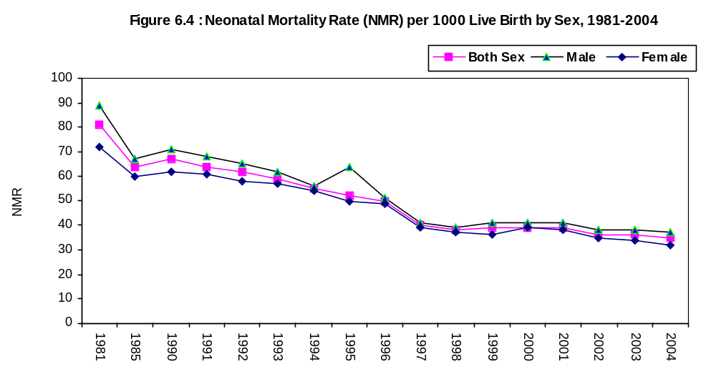

Division wise Variation in NMR: Neonatal Mortality Rate (NMR) is the mortality index of infants under one month of age. Divisionwise Variation in NMR can be seen in table T6.13. It is evident from the table that at the aggregate level NMR was the highest in Rajshahi division (39) followed by Dhaka division (39). It was the lowest in Khulna division (30). For male it was the highest in Rajshahi division (47) and the lowest in Barisal and Chittagong division (33). For female it was the highest in Sylhet division (34) and the lowest in Khulna division (24).
T6.13 Divisionwise Variation of NMR by Sex and Locality 1997-2004
Division | National |  |  | Rural |  |  | Urban
Division | Both Sex | Male | Female | Both Sex | Male | Female | Both Sex | Male | Female
1997
Barisal | 40 | 41 | 39 | 45 | 46 | 43 | 31 | 33 | 30
Chittagong | 41 | 42 | 40 | 46 | 48 | 45 | 33 | 35 | 32
Dhaka | 42 | 43 | 41 | 48 | 49 | 47 | 32 | 34 | 31
Khulna | 38 | 40 | 37 | 46 | 47 | 44 | 30 | 31 | 29
Rajshahi | 41 | 42 | 39 | 47 | 48 | 46 | 33 | 32 | 34
Sylhet | 39 | 40 | 38 | 45 | 46 | 44 | 30 | 34 | 29
1998
Barisal | 38 | 39 | 37 | 44 | 45 | 42 | 29 | 29 | 30
Chittagong | 39 | 40 | 38 | 43 | 44 | 43 | 32 | 30 | 32
Dhaka | 40 | 41 | 39 | 46 | 46 | 46 | 30 | 33 | 30
Khulna | 37 | 38 | 35 | 44 | 43 | 41 | 29 | 28 | 29
Rajshahi | 39 | 40 | 37 | 46 | 47 | 44 | 32 | 31 | 33
Sylhet | 37 | 38 | 36 | 43 | 44 | 42 | 29 | 32 | 29
2003
Barisal | 32 | 35 | 29 | 33 | 36 | 29 | 27 | 26 | 29
Chittagong | 31 | 35 | 26 | 32 | 37 | 28 | 24 | 28 | 19
Dhaka | 39 | 41 | 37 | 45 | 45 | 44 | 25 | 30 | 20
Khulna | 32 | 31 | 33 | 33 | 33 | 34 | 24 | 22 | 27
Rajshahi | 40 | 42 | 37 | 41 | 44 | 38 | 25 | 24 | 26
Sylhet | 37 | 40 | 35 | 38 | 40 | 36 | 25 | 28 | 23
2004
Barisal | 29 | 33 | 25 | 29 | 34 | 25 | 25 | 25 | 24
Chittagong | 30 | 33 | 26 | 32 | 34 | 29 | 20 | 28 | 12
Dhaka | 37 | 47 | 28 | 38 | 45 | 31 | 36 | 51 | 19
Khulna | 30 | 35 | 24 | 28 | 33 | 23 | 39 | 49 | 29
Rajshahi | 39 | 47 | 30 | 39 | 48 | 30 | 34 | 37 | 31
Sylhet | 37 | 39 | 34 | 37 | 40 | 34 | 33 | 29 | 37
630
68

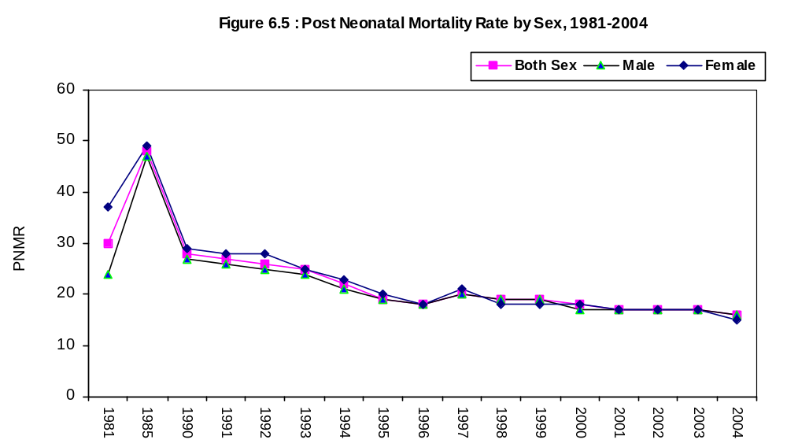
Division wise variation of PNMR : Division wise variation of PNMR by sex and locality for the period 1997-2004 can seen in table T6.15

T6.15 Division wise Variation of PNMR by Sex and Locality, 1997-2004

Division | Total |  |  | Rural |  |  | Urban
Division | Both Sexes | Male | Female | Both Sexes | Male | Female | Both Sexes | Male | Female
1997
Barisal | 20 | 21 | 20 | 22 | 22 | 22 | 16 | 17 | 15
Chittagong | 21 | 22 | 21 | 20 | 21 | 21 | 16 | 17 | 16
Dhaka | 19 | 20 | 18 | 21 | 21 | 19 | 17 | 18 | 16
Khulna | 20 | 19 | 23 | 22 | 19 | 23 | 15 | 16 | 14
Rajshahi | 21 | 20 | 24 | 20 | 18 | 26 | 16 | 15 | 16
Sylhet | 20 | 19 | 22 | 19 | 20 | 18 | 16 | 16 | 16
1998
Barisal | 19 | 20 | 18 | 21 | 21 | 19 | 15 | 16 | 14
Chittagong | 20 | 21 | 19 | 19 | 19 | 18 | 16 | 16 | 15
Dhaka | 18 | 19 | 16 | 19 | 20 | 18 | 16 | 17 | 16
Khulna | 18 | 18 | 19 | 20 | 18 | 19 | 14 | 16 | 13
Rajshahi | 20 | 19 | 22 | 19 | 16 | 18 | 16 | 17 | 16
Sylhet | 19 | 18 | 21 | 18 | 19 | 17 | 16 | 16 | 15
2003
Barisal | 26 | 25 | 27 | 27 | 26 | 28 | 17 | 20 | 14
Chittagong | 15 | 16 | 15 | 16 | 17 | 16 | 12 | 14 | 9
Dhaka | 19 | 19 | 18 | 19 | 21 | 18 | 17 | 16 | 18
Khulna | 15 | 17 | 14 | 16 | 17 | 14 | 12 | 12 | 13
Rajshahi | 17 | 14 | 20 | 17 | 14 | 20 | 15 | 13 | 16
Sylhet | 22 | 25 | 19 | 22 | 25 | 19 | 23 | 29 | 18
2003
Barisal | 21 | 26 | 15 | 22 | 27 | 16 | 6 | 10 | 2
Chittagong | 11 | 13 | 9 | 11 | 13 | 9 | 9 | 12 | 7
Dhaka | 18 | 20 | 16 | 18 | 19 | 18 | 17 | 23 | 11
Khulna | 11 | 14 | 8 | 9 | 9 | 9 | 21 | 39 | 2
Rajshahi | 20 | 18 | 23 | 21 | 19 | 24 | 10 | 12 | 8
Sylhet | 18 | 17 | 18 | 18 | 18 | 18 | 9 | 0 | 18
It is evident from the table that in 2004 PNMR was the highest in Barisal division (21) and lowest in Khulna and Chittagong division (11). In case of rural area it was the highest in Barisal (22) and the lowest in Khulna division (9). In case of urban area it was the highest in Khulna division (16) and the lowest in Barisal division (6).
70

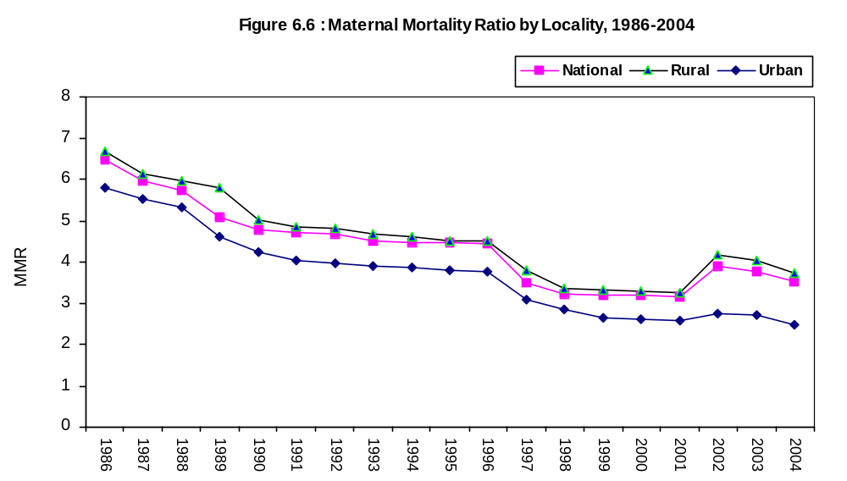
Regional Differentials in MMR
Divisionwise differentials in MMR can be seen in table T6.18. It is evident from the table that MMR in 2003 was the highest in Sylhet division (5.07) and was the lowest in Dhaka division (2.87). In case of rural area it was the highest in Sylhet division (5.17) and was the lowest in Dhaka division (3.09). In case of urban area it was the highest in Barisal division (4.54) and was the lowest in Khulna division 2.24.
T6.18: Maternal Mortality Ratio by Division and Locality, 2003 and 2004.
Division | 2004 |  |  | 2003
Division | Total | Rural | Urban | Total | Rural | Urban
Barisal | 4.38 | 4.56 | 2.87 | 4.67 | 4.68 | 4.54
Chittagong | 4.14 | 4.19 | 3.92 | 4.60 | 5.13 | 2.49
Dhaka | 3.51 | 4.07 | 2.17 | 2.87 | 3.09 | 2.41
Khulna | 3.95 | 4.25 | 3.36 | 3.05 | 3.22 | 2.24
Rajshahi | 3.96 | 4.02 | 3.38 | 3.91 | 4.04 | 2.81
Sylhet | 4.50 | 4.55 | 3.44 | 5.07 | 5.17 | 3.94
Total | 3.91 | 4.17 | 2.73 | 3.76 | 4.02 | 2.70

6.10 Cause Specific Death Rate
Cause specific death rates (CSDR) were estimated on the basis of the data collected by lay reporting system developed by WHO. Under this system data on causes of death were collected by the non- medical persons. Therefore, there are reservations on the level of accuracy of the indicator. Data on cause of death was collected on 64 specific causes and one open field for other causes. For simplicity in presentation these 64 causes have been grouped into 21 classes. CSDR is shown at tableT6.19 by sex and locality. It is evident from the table that Old Age (0.98) was the principal cause of death. It was followed by others diseases (0.90), Asthma and Respiratory disease (0.112), Blood Pressure and Heart disease (0.80), Fever (0.58) Suicide, Poisoning Drowning (0.46) etc. Principal causes of death by sex and locality are shown below:
73

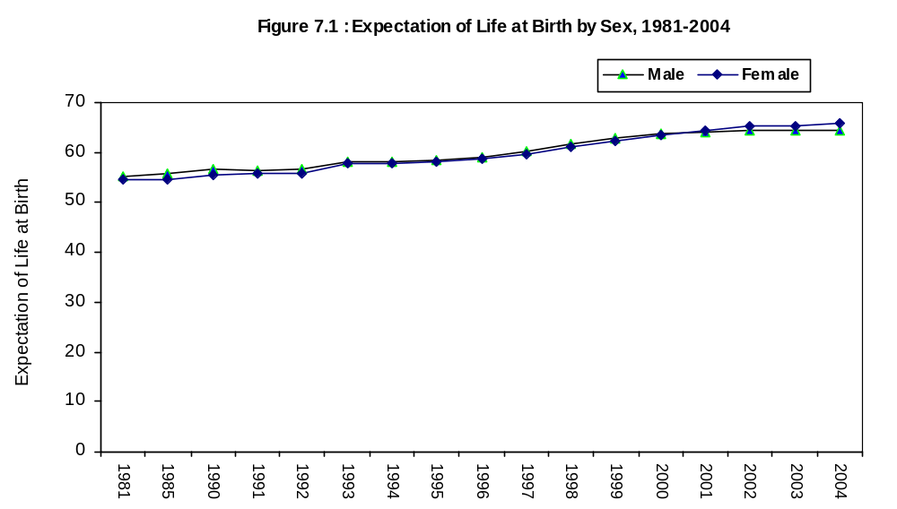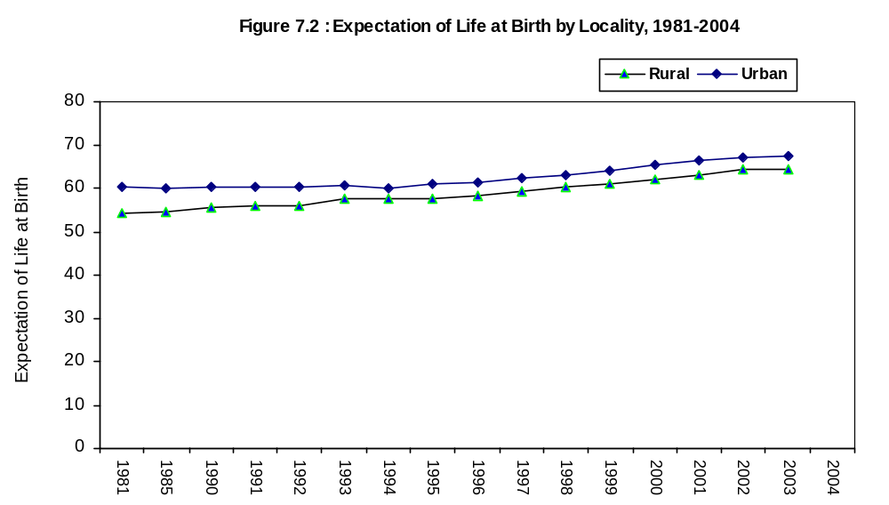
82

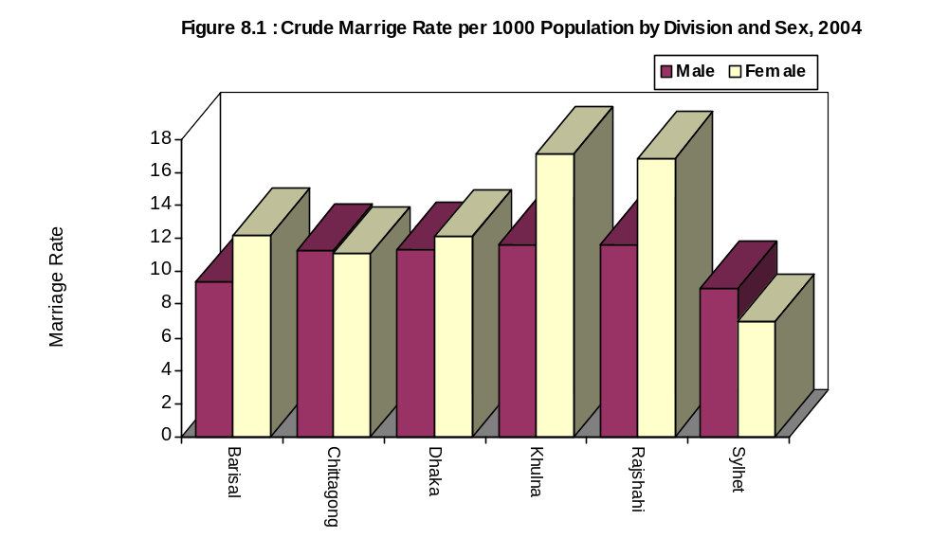
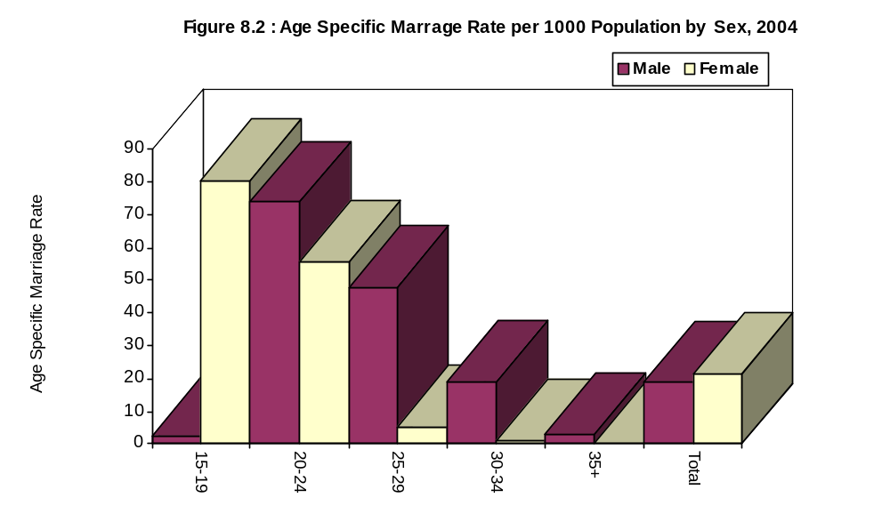
It is apparent from the table that ASMR for male was the highest (73.94) at the age group 20-24 and was the lowest (3.00) at the age-group 35+. In case of female it was the highest (80.40) at the age-group 15.19 and was the lowest (0.31) at the age-group (35+). In case of rural area ASMR for male was the highest at the age-group 20-24 (84.19) and was the lowest at the age-group 35+ (3.19) but in case of female it was the highest at the age-group 15-19 (92.00) and was the lowest in the age group 35+ (0.35). In case of urban area ASMR for male was the highest for the age group 20-24 (32.97) and was the lowest for the age group 35+ (2.22). ASMR for female was also the highest at the age group 15-19(38.88) and was the lowest in the age group 35+ (0.13).

87

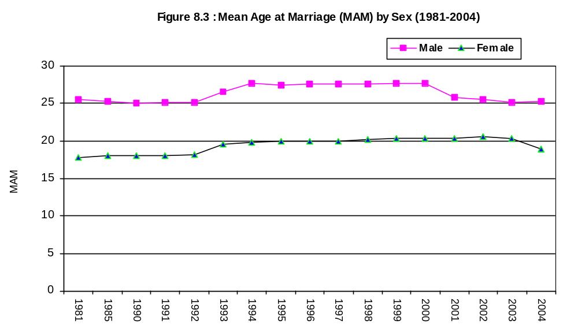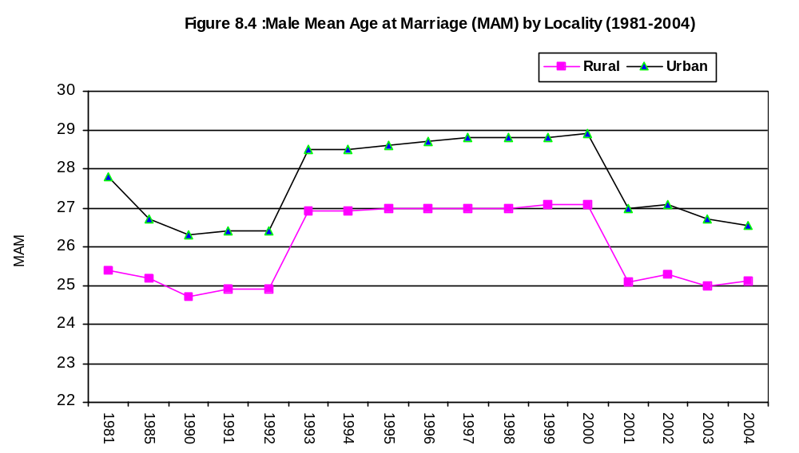
91

T8.12 Age Specific Divorce Rate by Age and Sex, 2004
Age-group | Both Sexes | Male | Female
15-19 | 2.07 | 0.28 | 4.13
20-24 | 2.41 | 1.00 | 3.61
25-29 | 1.25 | 1.07 | 1.40
30-34 | 0.63 | 0.60 | 0.65
35+ | 0.16 | 0.13 | 0.19
Total | 0.83 | 0.36 | 1.32
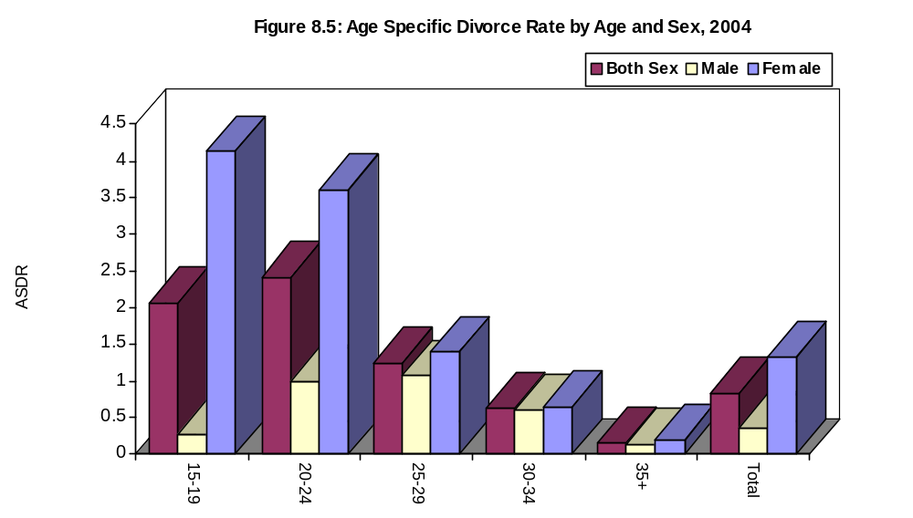

It is apparent from the tables that age specific divorce rate for female was the highest (4.05) at the age group 15-19 which was followed by 3.37 at the age group 20-24. For male it was the highest (0.98) at the age group 20-24 which was followed by 1.07 at the age group 25-29. The divorce rate for male was only a 0.13 at the age group 35+.

8.7.3 Age-Specific Separation Rate
Age specific separation rate has been calculated as the relative number of separation at a defined age group per 1000 population of that age group. Age specific separation rate as obtained in 2004 is shown at the table DS05 and T8.13.

95

T8.13 Age Specific Separation Rate by Age group and Sex, 2004
Age-group | Both Sexes | Male | Female
15-19 | 0.57 | 0.33 | 0.85
20-24 | 1.15 | 0.87 | 1.39
25-29 | 0.63 | 0.58 | 0.67
30-34 | 0.44 | 0.47 | 0.42
35+ | 0.16 | 0.14 | 0.17
Total | 0.91 | 0.71 | 1.12
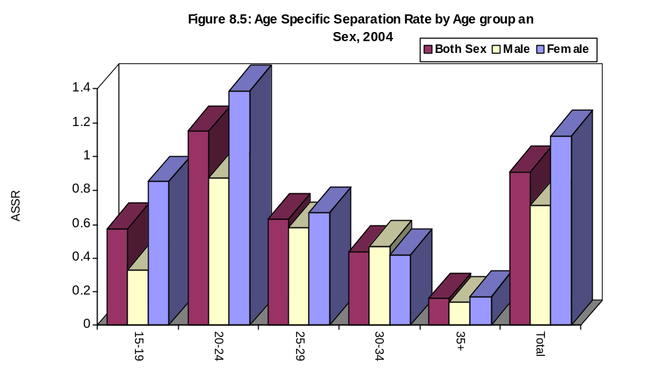
It is apparent from the table that age-specific separation rate for female was the highest (1.29) at the age group 20-24 followed by the age-group 15-19 (0.83). For male it was the highest (0.86) at the age group 20-24 followed by the age group 25.29 (0.57). There were least separation at the age group 35+ for both the males (0.14) and females (0.17).

8.7.4 Reasons for Divorce
Reasons for divorce as evidence from SVRS 2004 is shown at table DS06. It is apparent from the table that for male the main reasons for divorce were - Failure in conjugal life, characterless, dowry, inability in maintaining expenditure, child marriage. In case of female the main reasons for divorce were – inability in maintaining expenditure, physical tortures, re-marriage, dowry, failure in conjugal life, characterless, impotent. The table also shows the reasons for divorces for males and females in urban and rural areas.
8.7.5 Reasons for Separation
Reasons for separation are shown at table DS07. It is apparent from the table that for male the principal reason for separation were inability in maintaining expenditure failure in conjugal life, remarriage, dowry, missing child marriage. In case of female the principal reasons for separation were inability in maintaining expenditure, remarriage, physical torture, dowry characterless and failure in conjugal life. Urban-rural differentials can also be seen in the table DS07.
96

Chapter-9
Use of Family Planning Methods

The report presented here is the outcome of data collected through schedule-9 under SVRS. With schedule-9 data was collected on name, age, education and economic activities of couples, ever use of family planning method, method used, current use and name of method using. This chapter deals with the situation of ever use and current use of contraceptive methods in Bangladesh. The statistics shown here is very important since family planning is one of the main programme of the Government of Bangladesh.
9.1 Contraceptive Prevalence Rate(CPR):
Contraceptive Prevalence Rate (CPR) has been defined as the percentage of couple who has been currently using any method of contraception to currently married women of reproductive age. CPR by locality has been shown at T9.1. It is apparent that CPR is 7.4 percentage points more in urban area as compared to rural area. Levels and Trends in CPR over time can be seen in Table T9.1
T9.1 Contraceptive Prevalence Rate (CPR) by Locality (1975-2003)
Year | National | Rural | Urban
1975 | 7.7 | NA | NA
1990 | 39.7 | 38.6 | 46.8
1994 | 46.3 | 44.9 | 53.4
1995 | 48.7 | 43.9 | 57.1
1997 | 50.9 | 48.3 | 56.5
1998 | 51.5 | 48.9 | 56.6
2001 | 53.9 | 52.7 | 59.1
2002 | 53.4 | 51.7 | 60.1
2003 | 55.1 | 52.2 | 60.3
2004 | 56.2 | 53.5 | 60.9

It is evident from the table that as compared to 1975 CPR has increased many fold but as compared to 1990 it has increased by 41.6% during 1990-2004 with 38.6% in rural area and 36.1% in urban area

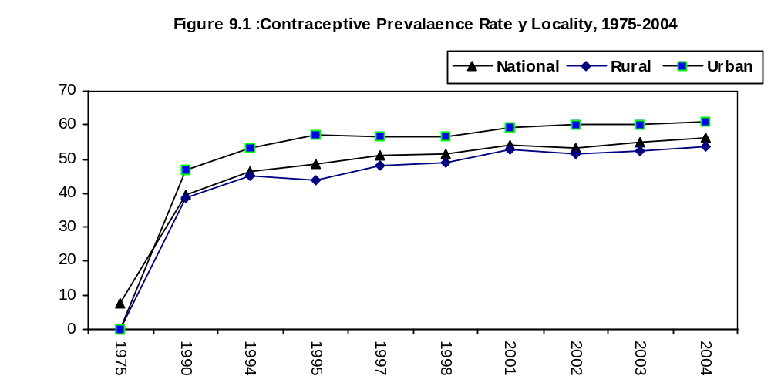
9.2 Ever Use of Family Planning Methods
Ever use of family planning methods in SVRS refers to the use at any time before the interview date without making distinction between past and current use. Any respondent reporting that she or her husband had used some form of contraception was included as an ever user regardless of the time of use. Thus, a reported ever user might be a past or current user. Use of contraceptive by age of mother and method of contraception is shown at table T9.2.
99

9.6 Locality wise Differentials of CPR
Urban-rural differentials in CPR has been shown in table C03 and also in table T9.7. The table contains data on CPR of currently married women showing variations at urban and rural levels.
T9.7 Contraceptive Prevalence Rate by Method and Locality, 2003 and 2004
Method | 2003 |  |  | 2004
Method | National | Rural | Urban | National | Rural | Urban
Any Method | 55.13 | 52.17 | 60.37 | 56.19 | 53.37 | 60.79
Any Modern Method | 50.19 | 47.76 | 54.51 | 51.16 | 48.37 | 54.12
Condom | 5.32 | 4.08 | 7.52 | 5.58 | 4.26 | 7.56
Oral pill | 32.35 | 31.70 | 33.49 | 32.84 | 32.31 | 33.44
Injection | 9.96 | 9.43 | 10.89 | 10.12 | 9.07 | 10.16
Male sterilization | 0.21 | 0.22 | 0.20 | 0.20 | 0.21 | 0.18
Female sterilization | 1.84 | 1.84 | 1.84 | 1.78 | 1.78 | 1.79
IUD | 0.62 | 0.57 | 0.71 | 0.64 | 0.64 | 0.66
Traditional Method | 4.88 | 4.40 | 5.73 | 5.03 | 4.53 | 6.08
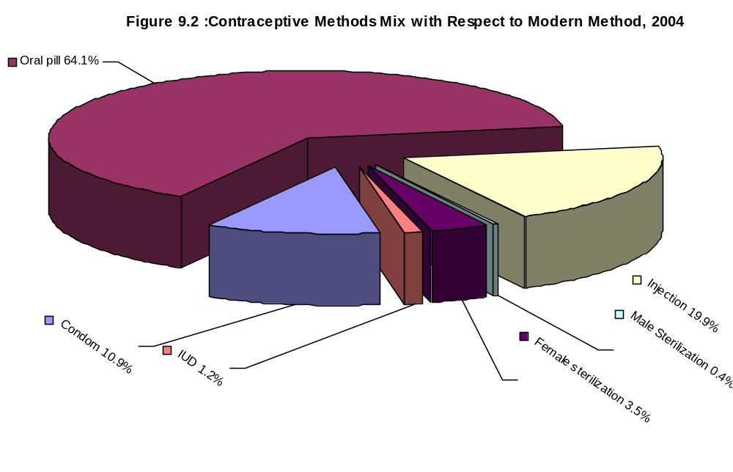It is apparent from the table that the overall rate of current use is higher in urban area than in rural areas. It was 60.79 percent among currently married women of urban areas as compared to 53.37 percent among women of rural areas.

102

It is also evident from the T10.2 that out-migration rates for national, rural and urban areas were 8.0, 7.3 and 13.3 respectively in 1984 and it is observed that 10.2, 8.8 and 17.2 in 1991. While in 2003 it was found to be 24.5, 14.8 and 42.6. It shows that it is increasing trend both in rural and urban areas.
T10.2 : In-migration Rate and Out Migration Rate per 1000 population, 1984-2003
Year | In-migration |  |  | Out-migration
Year | National | Rural | Urban | National | Rural | Urban
1984 | 6.8 | 5.8 | 14.5 | 8.0 | 7.3 | 13.3
1985 | 9.5 | 6.5 | 17.2 | 8.5 | 7.1 | 12.4
1986 | 14.2 | 9.6 | 30.5 | 10.6 | 8.2 | 10.4
1987 | 14.0 | 8.7 | 30.5 | 11.1 | 7.9 | 19.6
1990 | 16.2 | 12.9 | 31.2 | 10.1 | 9.2 | 18.0
1991 | 16.7 | 13.9 | 33.2 | 10.2 | 8.8 | 17.2
1992 | 17.5 | 14.7 | 35.2 | 12.1 | 10.2 | 19.2
1993 | 17.9 | 15.7 | 36.2 | 13.1 | 11.2 | 19.9
1994 | 18.0 | 15.9 | 36.4 | 13.2 | 11.5 | 20.0
1995 | 18.6 | 16.2 | 36.7 | 13.4 | 12.0 | 20.3
1996 | 19.0 | 16.9 | 37.0 | 13.5 | 12.3 | 20.7
1997 | 19.5 | 17.2 | 37.2 | 13.7 | 13.2 | 21.1
1998 | 18.9 | 16.5 | 36.8 | 13.4 | 12.9 | 20.8
1999 | 21.3 | 13.2 | 42.7 | 14.7 | 13.3 | 21.0
2000 | 22.2 | 13.7 | 44.7 | 15.8 | 14.1 | 21.5
2001 | 22.6 | 14.0 | 45.4 | 17.3 | 16.0 | 22.7
2002 | 27.3 | 13.0 | 50.8 | 19.8 | 14.3 | 30.1
2003 | 27.7 | 13.1 | 51.7 | 24.5 | 14.8 | 42.6
2004 | 28.6 | 17.0 | 47.5 | 28.6 | 19.9 | 54.4
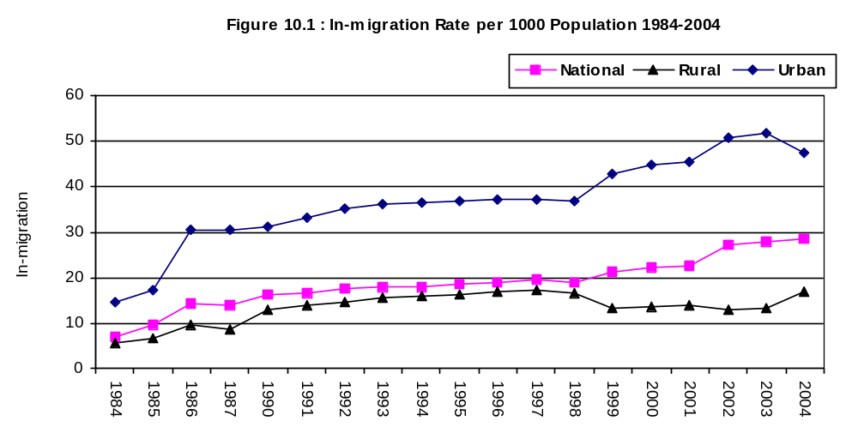

10.3 : Volume of Migration by Direction of Migration
Estimated number of migrants by direction of migration in Bangladesh for 1993-2003 is shown in Table T10.3. In 1991 total number of migrants were 1726 thousand of which 638 thousand were males and 1088 thousand were female . In 2001 it has increased to 2750 thousand of which 1094 thousand were male and 1656 thousand were females. Therefore population movement has increased over the years. In 1991 number of rural to rural migrants were 801 thousand and urban to urban migrants were 450 thousand. In 2003, the corresponding number increased to 1431 thousand and 1292 thousand.

106

102

